Topology selection:

In order to drive the given motor many different solution and topology can be used, however, in this part one explained 2 thyristors topologies and diode rectifier with buck converter and these topologies advantages and disadvantages

1)Tyhristor Topologies

Thyristors are controlled rectifiers which are used for HVDC application. By sending controlled pulses to gate terminals power output and voltage output controlled by changing firing angle. Moreover, thyristor has advantage of working two quadrants as rectifier which power flows from grid to load and as inverter (needs active source at load) which power flows from load to grid. The first thyristor topology is Single phase fully controlled rectifier.

1. Single phase fully controlled rectifier (may need isolate the firing angle from the circuit?????? )

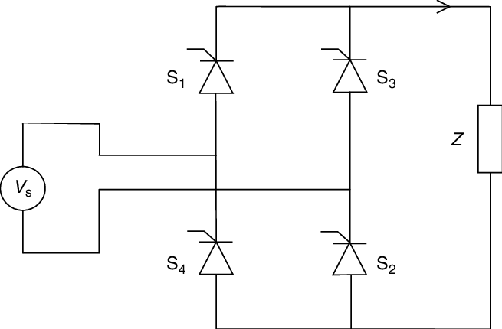

Figure . Single Phase Controlled Rectifier Schematic

The single phase fully controlled rectifier topology can be observed at figure x there are 4 thyristors work with 2 phases which need 180-degree phase difference between firing angles at the first S1 and S4 opened at second phase S3 and S2 open and conduct. The output phase voltage formula is

$$Vavg=\frac{2\sqrt{2} Vph }{π}cosα$$

Due to single phase, there is high voltage ripple at the output which can be reduced by adding a high capacitor with high capacitance at the output.

Advantages:

- Two quadrant work both as inverter and rectifier.

-With another single phase-controlled rectifier connected reverse direction the rectifier can work at all four quadrants.

-It is cost friendly comparing the three-phase due to lower number of thyristor (4) used.

Disadvantages:

-High voltage ripple at the output.

- Hard to arrange firing angles simultaneously and needs for additional circuits and source to open thyristors

-Lower average output voltage comparing to three phase one.

-Large harmonics in the input current

-low power factor and dpf for smaller output voltage.

1. Three phase fully controlled rectifier

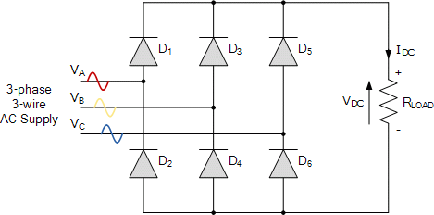

Figure . Three phase thyristor rectifier topology

Advantages

-Two quadrant operation, with additions it can be increased to work at 4 quadrant operation

-Lower voltage ripple

-Higher average output voltage

-More efficient comparing to other rectifier topologies.

Controlled voltage and power flow??????

Disadvantage

-Desynchronization problem since 6 thyristors must be synchronal.

-More complicated comparing to single phase

-lower pf and dpf comparing to diode rectifier

2)Diode rectifier and buck converter

Advantages:

-Low ripple dc signal

-Opportunity to adjust output voltage

-Easy to construct just need one timer as an extra

-No needs for pulse generator circuit like controlled rectifiers

Disadvantages:

-????Buck converter needs inductor to work

-needs additional h bridge to implement four quadrant operation

Final decision